**CS-4 Control Board**

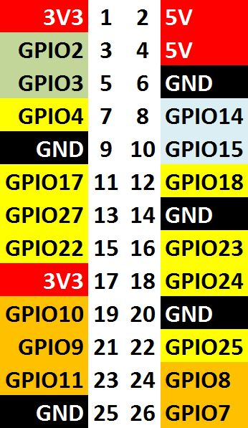

Resistors are 390 Ohm

to GPIO4 --------|>------^^^^^^-------- to GND READY

to GPIO 17 --------|>------^^^^^^-------- to GND INPUT

to GPIO27 --------|>------^^^^^^-------- to GND OUTUT

to Pin 2 OR 4 --------|>------^^^^^^-------- to GND POWER